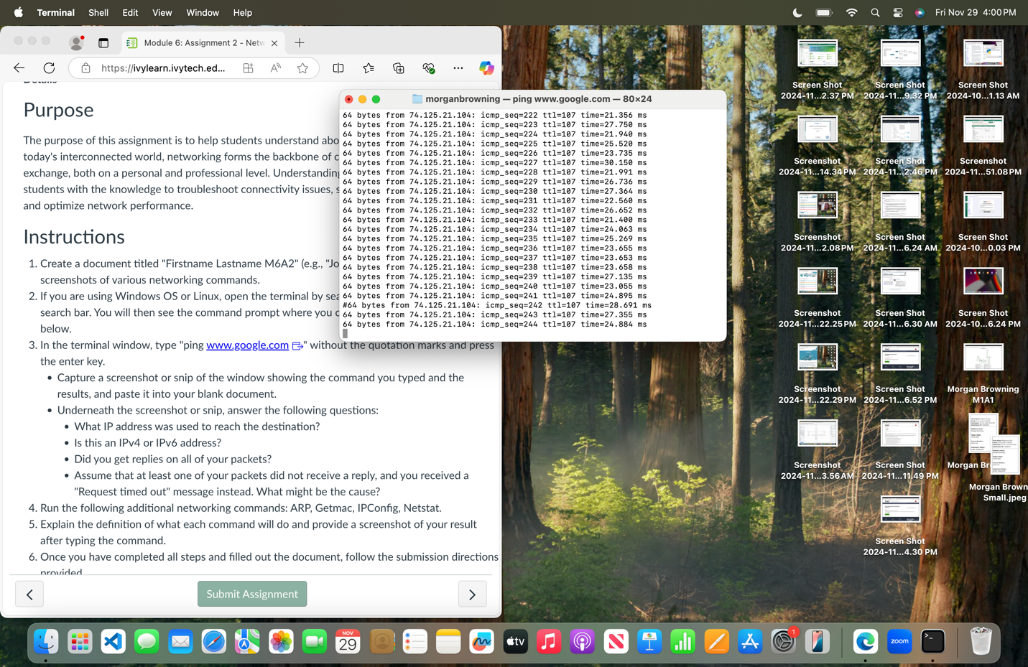

* What IP address was used to reach the destination?

74.125.21.104

* Is this an IPv4 or IPv6 address?

IPv4

* Did you get replies on all of your packets?

Yes, none of them failed

* Assume that at least one of your packets did not receive a reply, and you received a "Request timed out" message instead. What might be the cause?

The most likely cause would be network congestion followed by packet loss due to interference or weak signals.

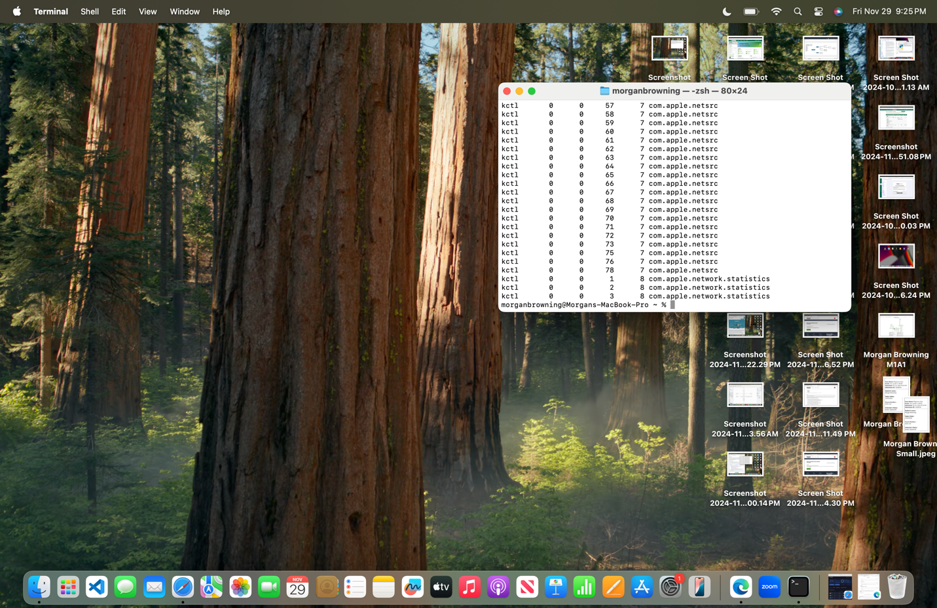

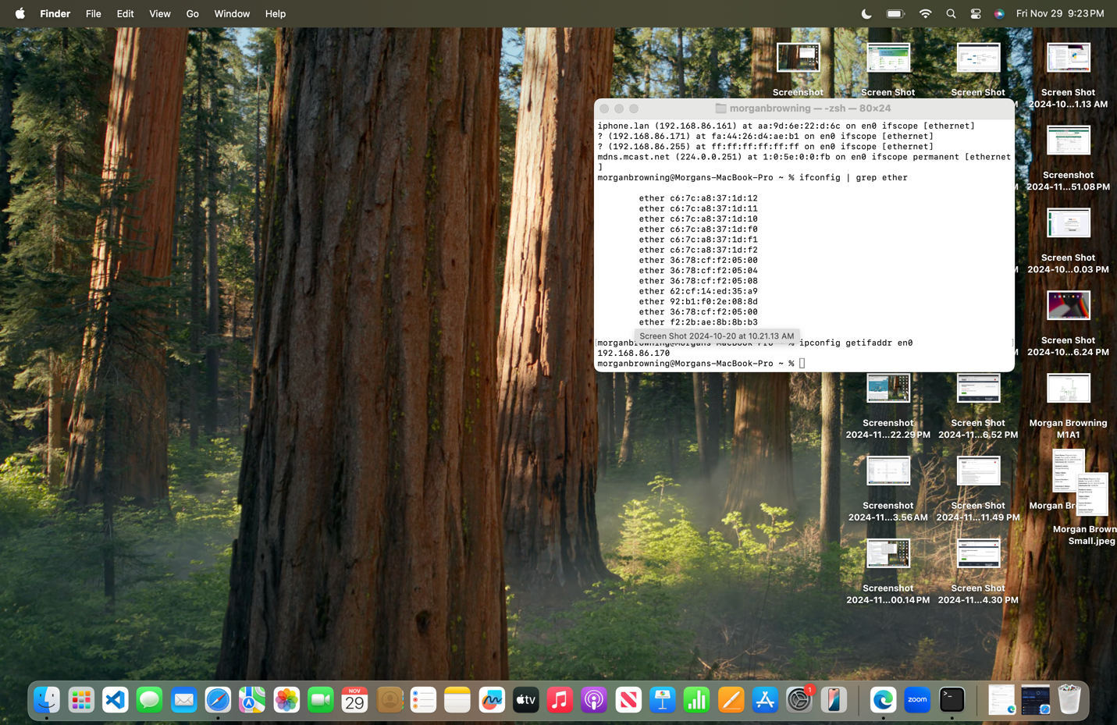

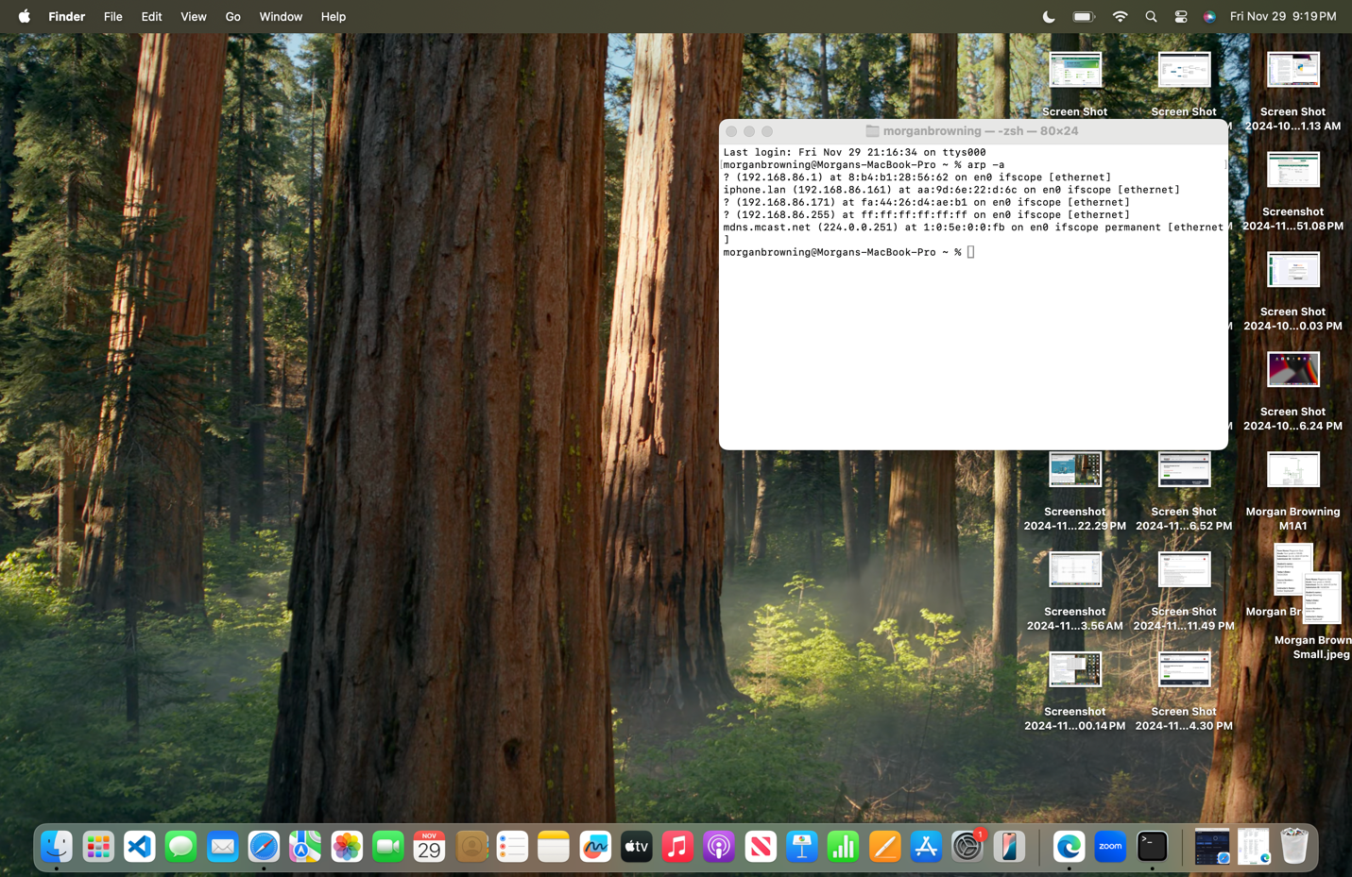

1. **ARP**: Shows a list of devices on your network and their IP to MAC address connections. Useful for checking what’s connected.
2. **Getmac**: Lets you see the unique MAC address of your network hardware. Helps identify your device on the network.
3. **IPConfig**: Shows your device's network setup, like IP address and connection details. Handy for fixing network issues.
4. **Netstat**: Displays active connections and network activity. Good for spotting open ports or strange activity.